|  |
| --- |
| CMS PRoject proposal  Warmahordes CMS |
| Mark Nunez WEBD-2006 Section 1  February 8, 2018  Phone 204-990-7343  Email marknunez917@gmail.com |

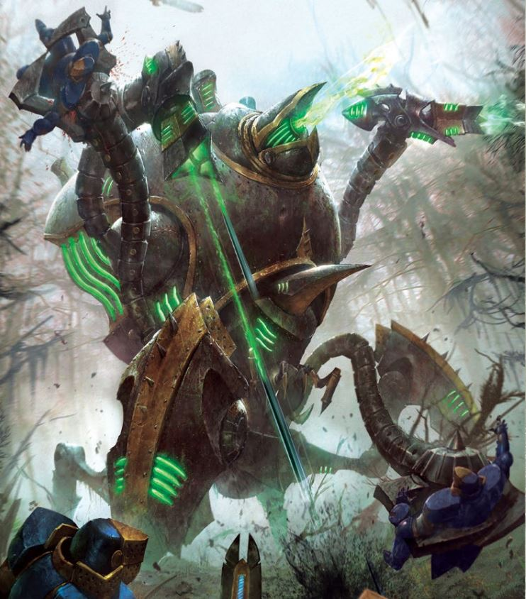

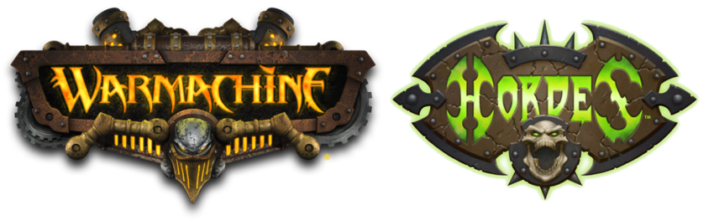

## Warmahordes CMS Project

### **Objective:**

Warmachine is a competitive tabletop war game created by Privateer Press, where players will pit armies of different factions against each other. As the popularity of the game increased, the Hordes expansion of the game was added. With the added content, the community started to grow at a rate that a form of organization was needed.

This project’s aim is to create a community base content management system to better assist these players to:

* Better coordinate Exhibition matches.
* Simplify access to participate in tournaments.
* Share army builds and get feedback.
* Get updated information on rules and model updates.
* A way to introduce new players to the community.

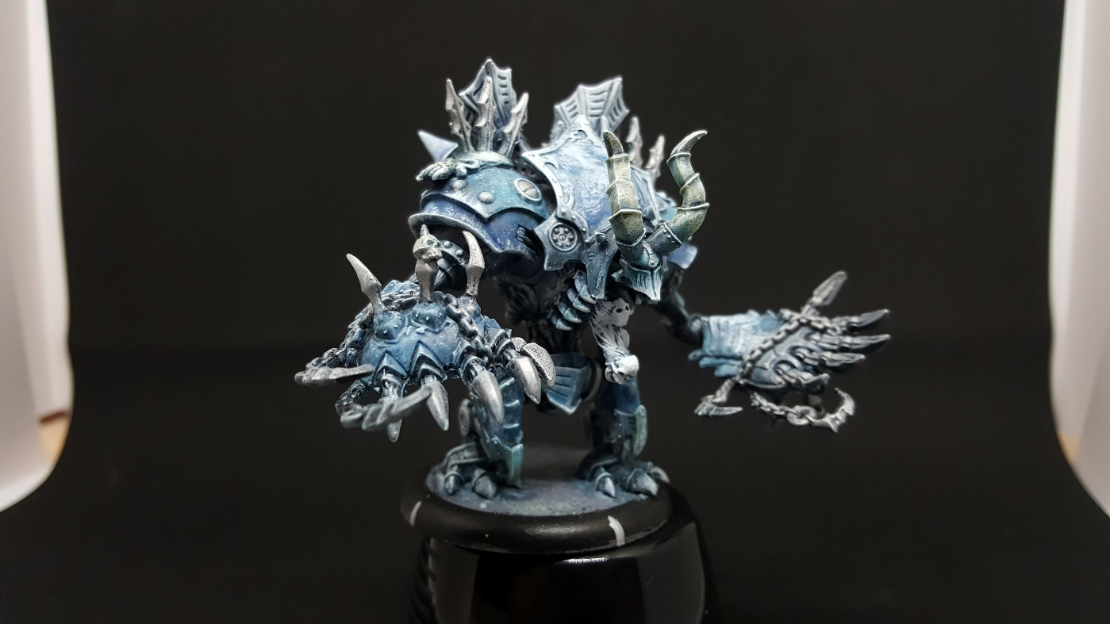

Figure 1 Cryx Death Jack – assembled and painted by: Mark Nunez

#### Users

Administrator:

* Can authorize and remove any type of user.
* Can update the list of official models that can be used in the army builder.
* Can approve of any events or news added to the news blog.
* Can remove any posts in the forum made by any user.
* Full access to create, update or delete any of the web pages on the main website.
* Can change the access of any given user.

Moderator:

* Can report any user below the administrator level to flag for review due to improper use of the CMS.
* Can remove any posts in the forum.
* Can post in the events and news blog.
* Can report an update for the army builder for the administrator to review.

Event User:

* They will be able to post in the event/news blog.
* They will be able to see if any user has applied for the event.
* They will be able to email any user that has applied.
* This can only be registered by companies or hobby shops that run tournaments.
* Must be approved by an administrator.

Registered User:

* This will be the most common type of user and will be authorized by an email sent to the applicant.
* They will have access to view the news blog and able to post in the forums.
* They can view and use the army builder. Their army will be saved in their profile.
* They can view and apply to events. A notification will be sent to the user via email stating they have applied and a reminder notification will be given a day before the event.

Guest User:

* Anyone viewing the website can see the news/events blog.
* They can access the army builder but cannot save army built until they register and login as a registered user.
* They can view the forums but not be able to post until they become a registered user.

**ERD**

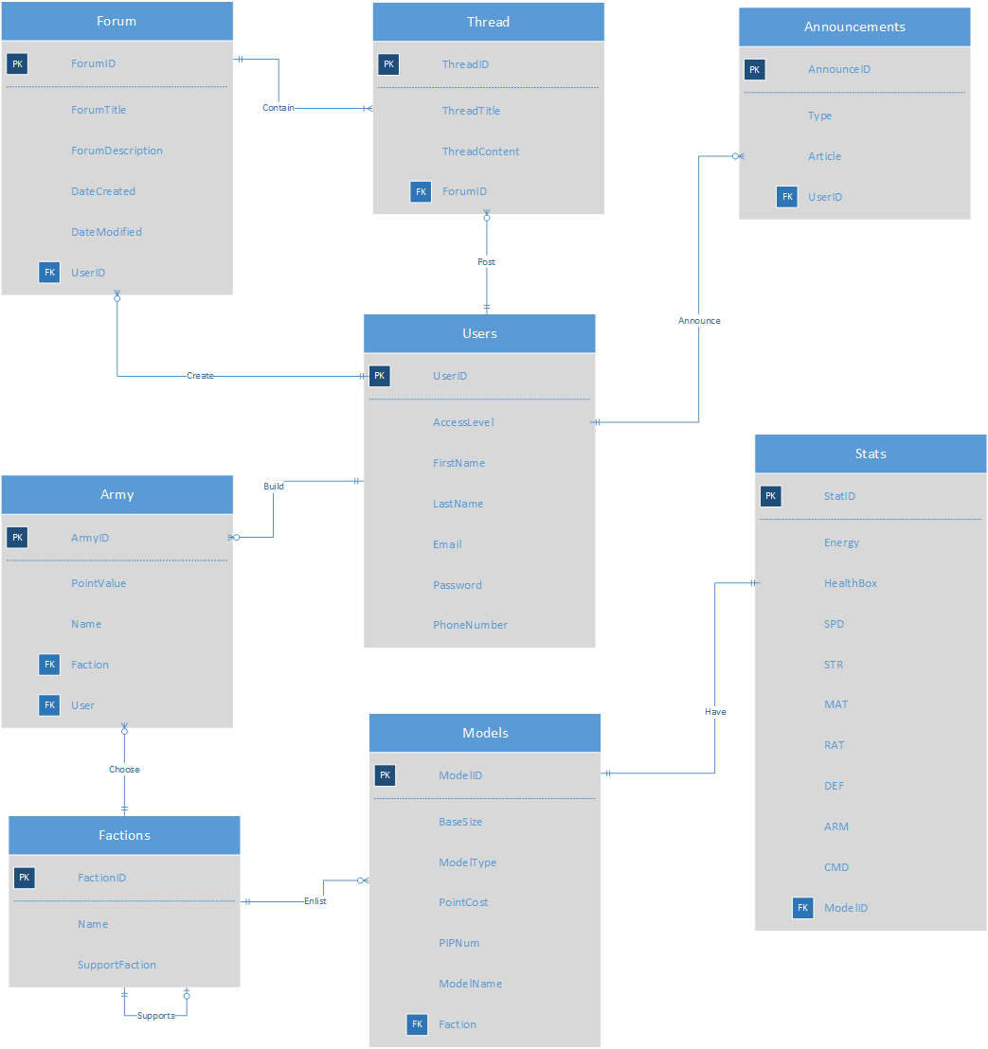

**TABLES**:

Users:

* Will contain all the user information and what level of access they have.

Forum:

* Table contains the various forums that will be created.

Thread:

* The content found in each Forum.

Announcement:

* Contains information of the various announcements that will be posted like events or updates to game play.

Army:

* The table containing information of the army being built.

Factions:

* Will have the type of factions to choose from and if needed, the support faction to add on top.

Models:

* All the models currently available in the game.

Stats:

* The stats of the model chosen.